BASH SCRIPTING
- Create a bash script to check if a directory is available or not.
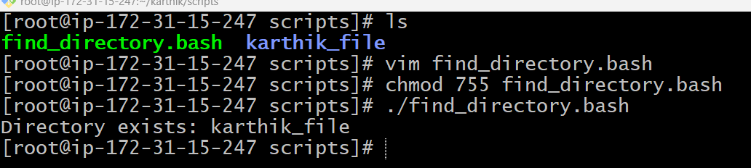
- Create a bash script to create multiple files.
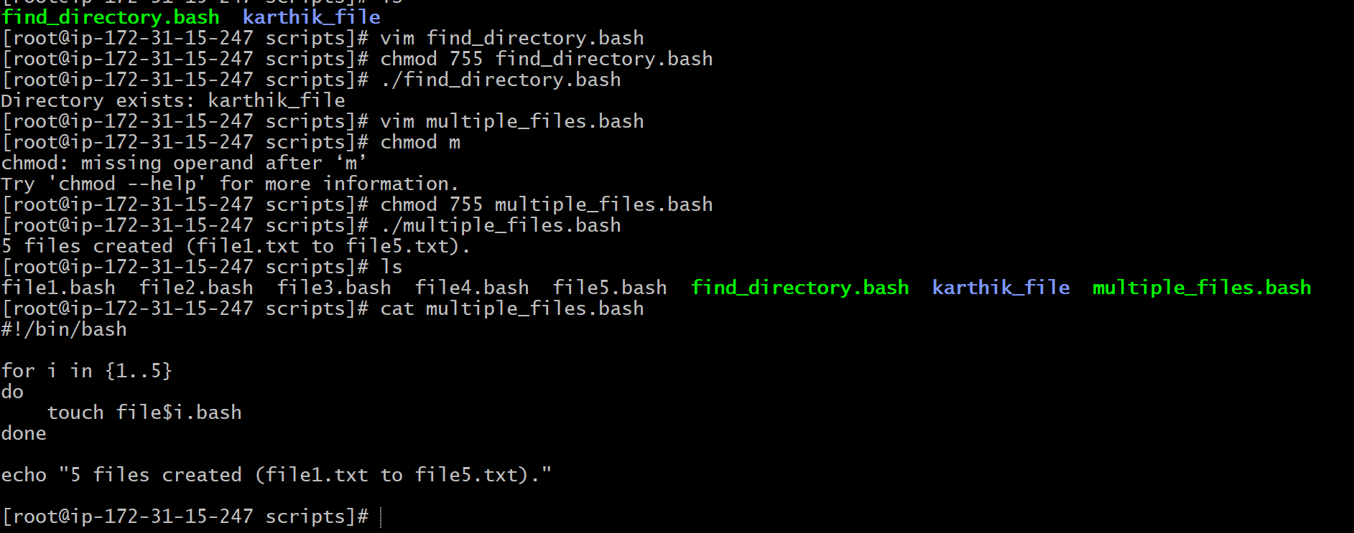

- Create a bash script to take a backup of a directory.
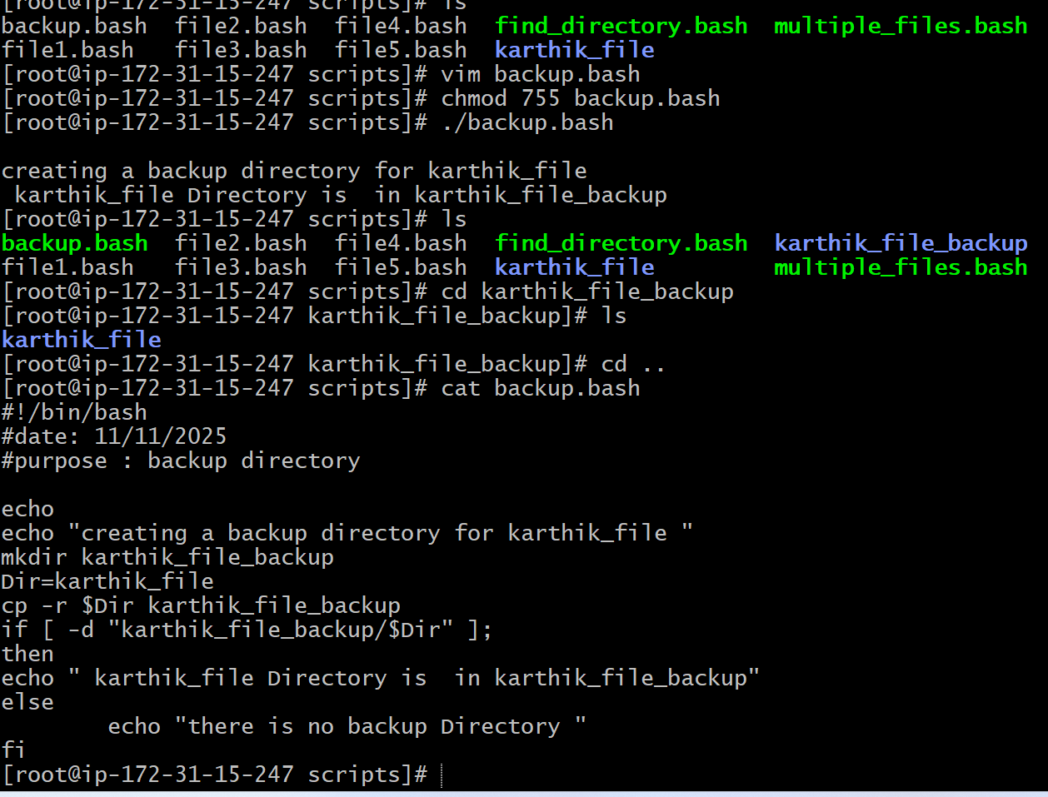
- Create a bash script to install Nginx on an EC2 server.
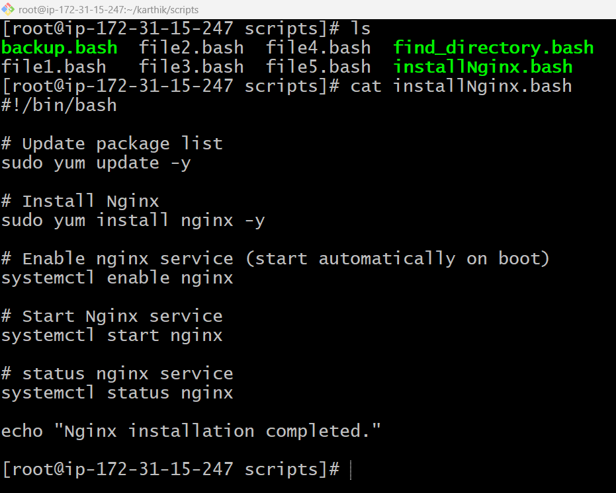
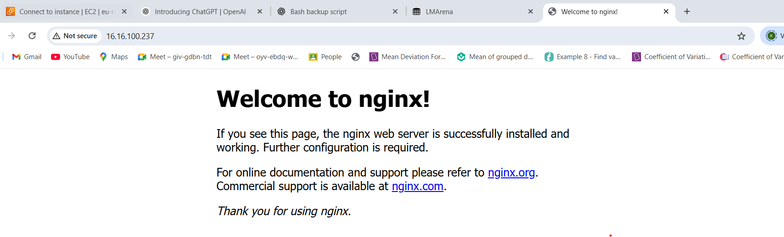

- Create a bash script to install Apache Tomcat on an EC2 server.
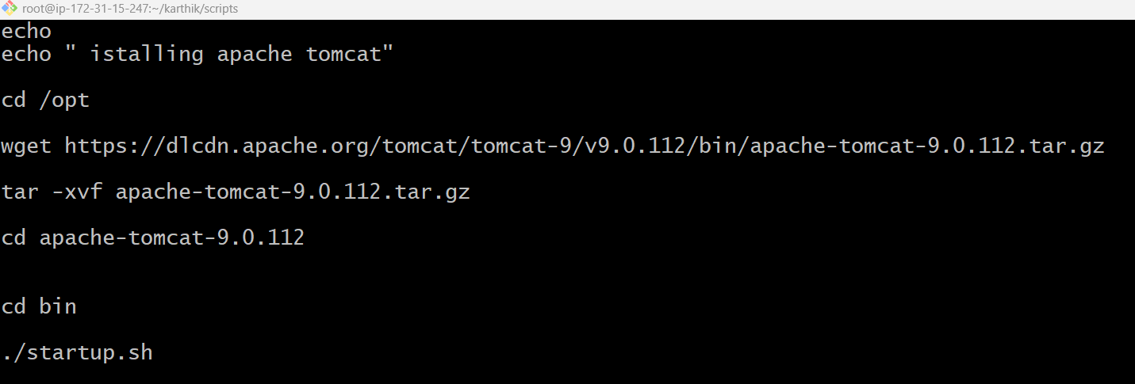
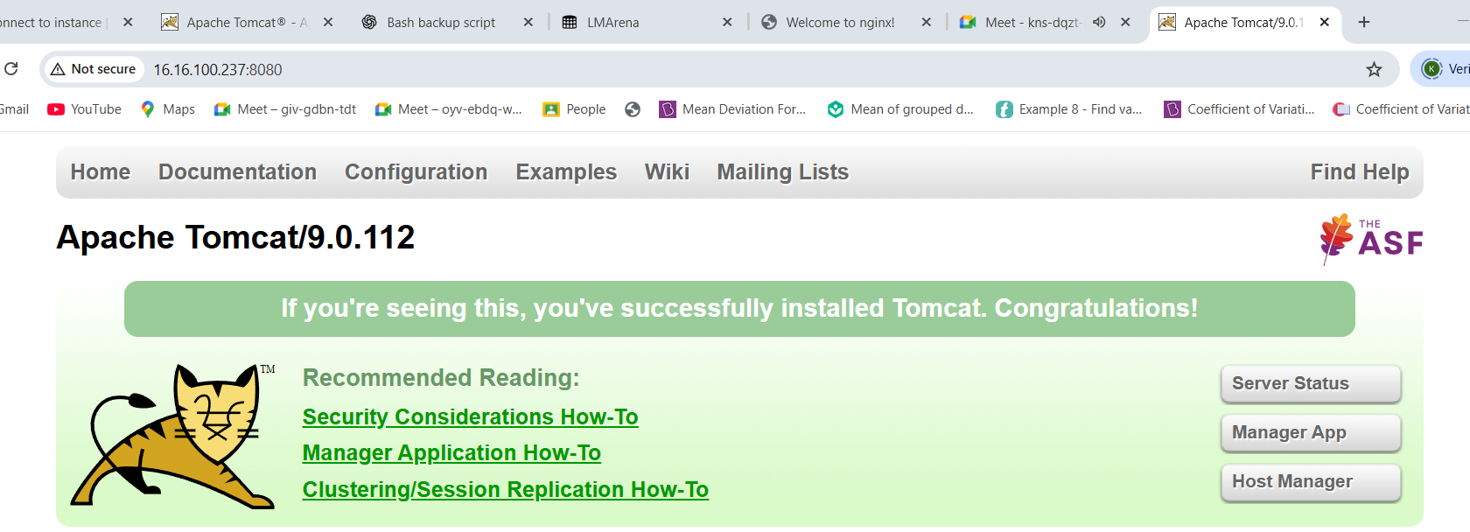

- Create a bash script to check if the Nginx service is running, if not running then script
should start the service.
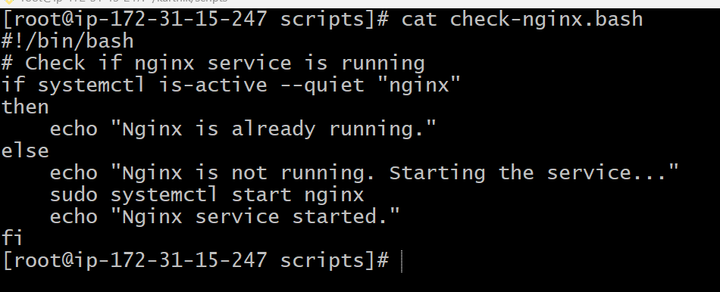
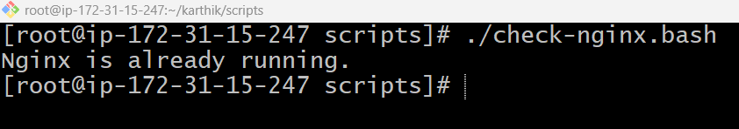

- Create a bash script for a calculator.
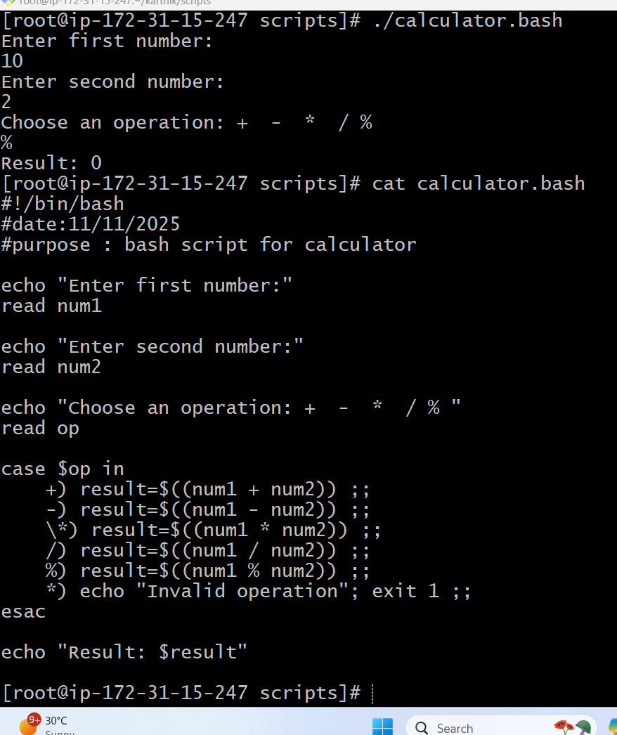

8Create a bash script to check if a directory exists, if not then create a directory.
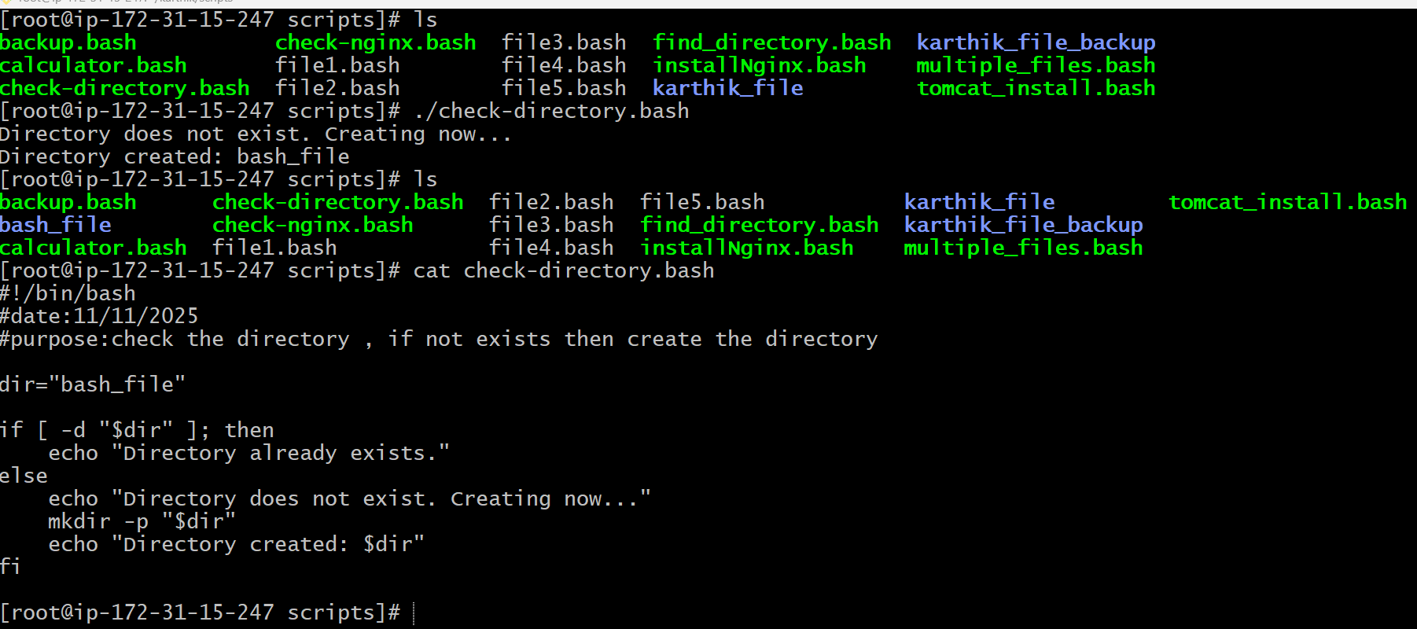

- Create a bash script to delete the last 3 lines of a file.
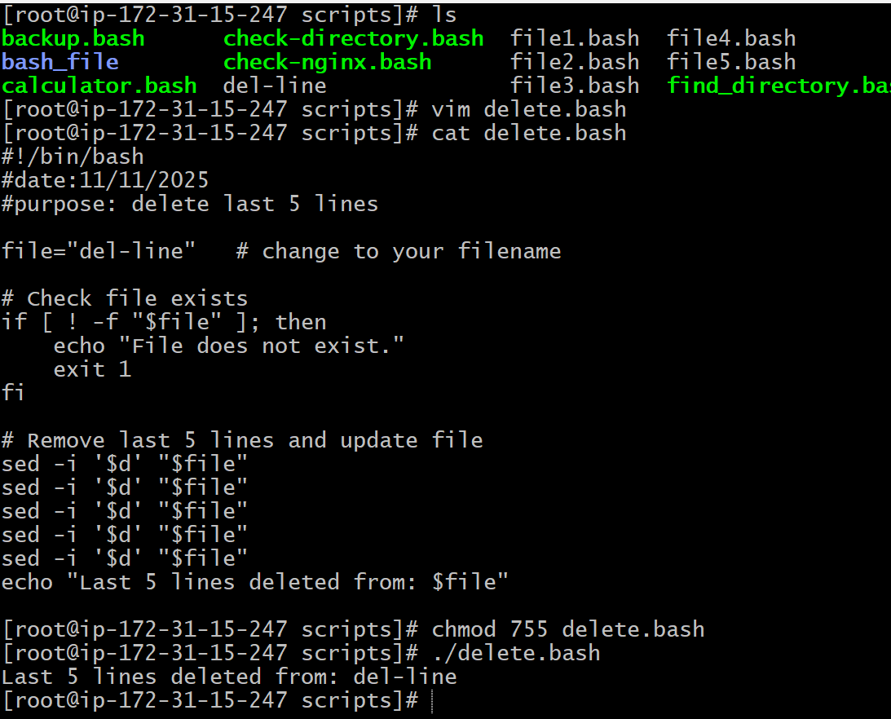

10. Bash script to monitor cpu and if it is more than 80% then send email notification
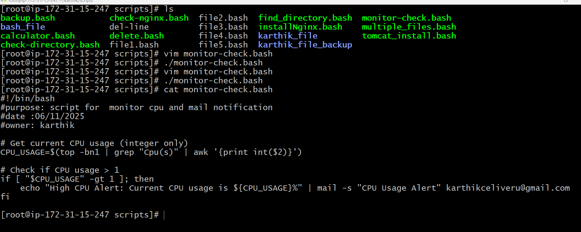
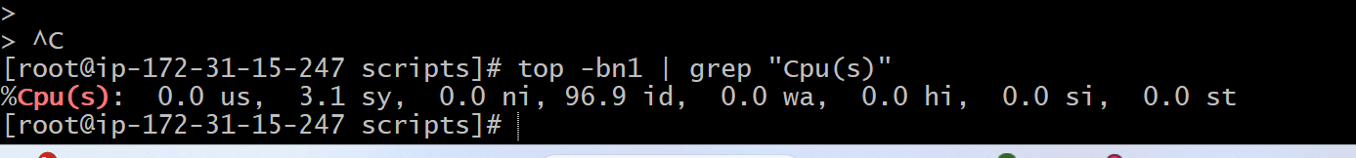
11. Bash script to monitor disk space and if it is more than 80% then send email notification
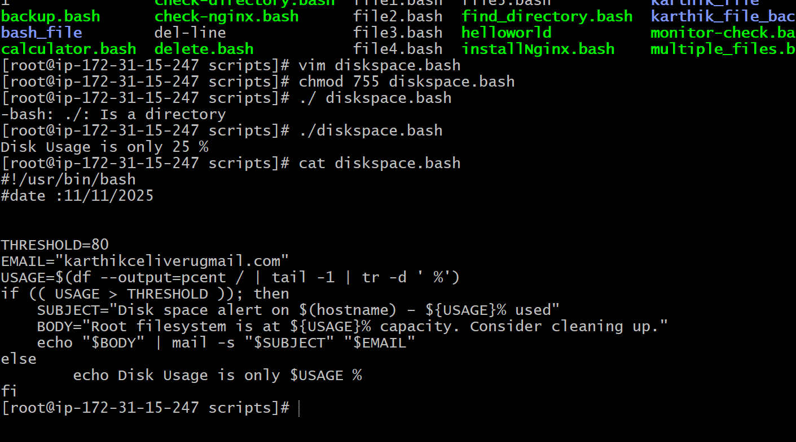

- Bash script to monitor memory and if it is more than 80% then send email notification.

